D.3 Human Evolution

**D.3.1. Outline the method for the dating of rocks and fossils using radioisotopes, with reference to 14C and 40K.**

*Accurate dating of fossils allows accurate sequencing of fossils*

*Select appropriate radioisotope*:

* 14C for young samples, from 1,000 to 100,000 years old
* 40K for older samples, over 100,000 years old

*Extract isotopes from sample*:

* some fossils contain radioisotopes
* many igneous rocks contain radioisotopes
* may be in the same strata as fossils
* may be in younger or older strata than fossils, allowing age bracketing

*Measure isotopes in sample*: proportion of 14C, or 40K, relative to breakdown products, 14N or 40Ar

* 14C/14N decreases over time at a predictable rate (half-life = 5730 years)
* 40K/40Ar decreases over time at a predictable rate (half-life = 1,250,000 years)
* compare 14C/14N and 40K/40Ar ratios with decay curve to determine age of sample

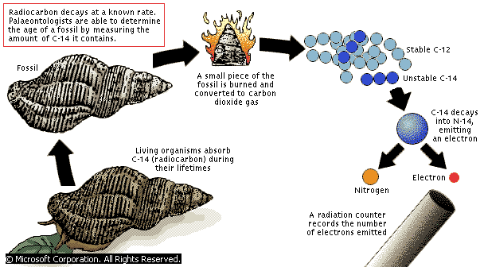

**D.3.2. Define half-life** = the time during which the radioactivity falls to half its original level

**D.3.3. Deduce the approximate age of materials based on a simple decay curve for a radioisotope.**

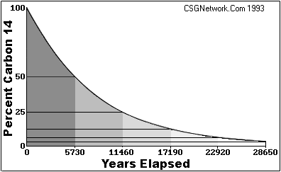

**D.3.4. Describe the major anatomical features that define humans as primates.**

*Primata = an order of mammals, including apes, monkeys, tarsiers and lemurs*

*Humans share the following characteristics with other Primates*

* grasping limbs, with long fingers and a separated opposable thumb;
* mobile arms, with shoulder joints allowing movement in three planes and the bones of the shoulder girdle allowing weight to be transferred via the arms;
* stereoscopic vision, with forward facing eyes on a flattened face, giving overlapping fields of view;
* skull modified for upright posture;

*Thus, it is clear that all primates share a common ancestry*

**D.3.5. Outline the trends illustrated by the fossils of *Ardipithecus ramidus*, *Australopithecus*, including *A. afarensis* and *A. africanus*, and *Homo*, including *H. habilis*, *H. erectus*, *H. neanderthalensis* and*H. sapiens*.**

*Hominidae is a family within the order Primata which is defined by bipedal locomotion*

*Trends in hominid evolution:*

* increasing adaptation to bipedalism, especially forward movement of foramen magnum
* increasing brain size in relation to body size

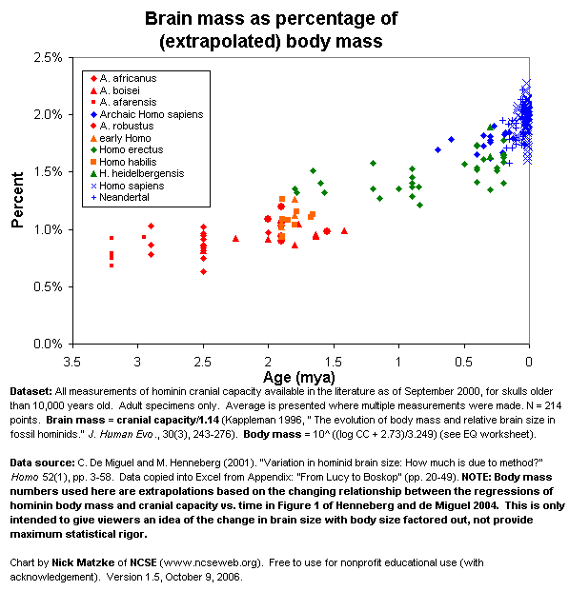

* hominids originated in Africa and spread to other continents
  + *Ardipithecus* fossils found in Ethiopia
  + *Australopithecus* and *Homo habilis* fossils found in Southern and Eastern Africa
  + *Homo erectus* fossils found in Eastern Africa and in Asia
  + *Homo neanderthalensis* fossils found in Europe
  + *Homo sapiens* fossils found in all continents except Antarctica
* decreasing relative size of: face, jaw, teeth, esp. canines; increasing relative size of brain case, forehead

**D.3.6. State that, at various stages in hominid evolution, several species may have coexisted.**

* a number of *Australopithecus* and *Homo* species probably coexisted in Eastern and/or Southern Africa
* *Homo neanderthalensis* and *Homo sapiens* probably coexisted in Europe

**7. Discuss the incompleteness of the fossil record and the resulting uncertainties with respect to human evolution.**

* because the hominid fossil record is incomplete, it is unclear how the various hominid species are related
* the fossil record for hominids is incomplete because it is difficult for remains of animals living in arid or semi-arid habitats to fossilize
  + fossils only form when buried under sediment before decomposition occurs;
  + animal bodies are usually easten by detritivores, decomposed by bacteria, or broken down chemically
    - for example, organic acids react with alkali in bones and teeth
  + therefore, few fossils found of savanna-dwelling hominids;
  + of remains fossilized, most remain buried in sediment/ remain unfound;
  + hominid fossils that have been found may or may not be representative of hominid history;
  + hominid fossils that have been found are usually partial, and the remainder of the organism must be inferred/ inferences may or may not be correct;
  + only hard parts of individuals fossilize, leaving many questions concerning the rest of the individual’s phenotype;

**8. Discuss the the correlation between the change in diet and increase in brain size during hominid evolution.**

* Early hominids (*Australopithecus*)
  + brain sizes were similar in size to those of apes
  + powerful jaws and teeth indicate mainly vegetarian diet
* About 2.5 million years ago Africa became much cooler and drier
  + savannah grassland replaced forest
  + may have prompted evolution of *Homo*
    - increasingly sophisticated tools
    - change to hunting and killing large animals, increasing meat in diet
* change in diet corresponds to the start of increase in hominid brain size
  + in apes and early hominids, brain growth slows after birth
  + but *Homo* has rapid brain growth after birth
* possible explanation
  + eating meat increases supply of protein, fat and energy, making larger brain growth possible
  + hunting and killing prey on savannas is more difficult than gathering plant foods, so natural selection might have favored larger brains with greater intelligence
* bipedalism is characteristic of *Australopithecus* genus;
* dating to at least 3.6 million years ago;

**D.3.9. Distinguish between *genetic* and *cultural* evolution.**

*genetic evolution*: product of selection for genes producing large brains capable of learning

* genes produce the abilities to learn language
* genes produce the abilities to learn about natural history
* genese produce the abilities to learn complex social information

*cultural evolution*: the specific learning done by groups of people sharing similarly selected large brains

* culture produces specific languages
* culture produces specific natural history information
* culture produces specific complex social information

*genetic evolution = nature*:

* inherited vertically between generations;
* physically inherited as genes coded within DNA;
* change is random, through mutation;
* natural selection determines likelihood of inheritance;
* acquired characteristics are not inherited;
* occurs slowly as gene pools alter gradually;

*cultural evolution = nurture*:

* inherited vertically, horizontally, or saltationally between any group, across any time or distance;
* inherited physically or non-physically, independent of DNA;
* change can be random or directed by intelligence;
* selection determines likelihood of inheritance;
* acquired characteristics can be inherited;
* can occur at any rate, typically much more rapidly than genetic evolution, and even instantaneously

*there is no nature without nurture, and no nurture without nature*

**D.3.10. Discuss the relative importance of genetic and cultural evolution in the recent evolution of humans.**

* cultural evolution has played an increasingly greater role in the lives of humans over time;
* especially over the past few thousand years, during which human characteristics have changed hugely
* genetic change happens too slowly to produce the huge changes in human culture;
* some cultural changes have, such as medical advances, have reduced natural selection pressures between phenotypes